GANPAT UNIVERSITY
U.V.PATEL COLLEGE OF ENGINEERING & TECHNOLOGY
Department of Computer Science and Engineering
B.Tech 1ST Semester Subject – ESFP
First Name:Bhavya patel Enrollment Number:14012121004 Stream:BDA

Assignment -1 Date:27/08/14

Deliverable :
1. Source code
Q1. Write a program to print ASCII values of all backslash characters and white space on screen in following format :
The ASCII value of ‘\t’ is : 9
Ans. #include<stdio.h>
#include<conio.h>
void main()
{
char a;
clrscr();
a='\a';
printf("\nthe ascii value of'\\a' is:%d",a);
a='\b';
printf("\nthe ascii value of '\\b' is:%d",a);
a='\f';
printf("\nthe ascii value of '\\f' is:%d",a);
a='\n';
printf("\nthe ascii value of '\\n' is:%d",a);
a='\r';
printf("\nthe ascii value of '\\r' is:%d",a);
a='\t';
printf("\nthe ascii value of '\\t' is:%d",a);
a='\v';
printf("\nthe ascii value of '\\v' is:%d",a);
a='\'';
printf("\nthe ascii value of '\\'' is:%d",a);
a='\"';
printf("\nthe ascii value of '\\''' is:%d",a);
a='\?';
printf("\nthe ascii value of '\\?' is:%d",a);
a='\\';
printf("\nthe ascii value of '\\\' is:%d",a);
a='10';
printf("\nthe ascii value of '10' is:%d",a);
getch();
}
Outcomes / Output 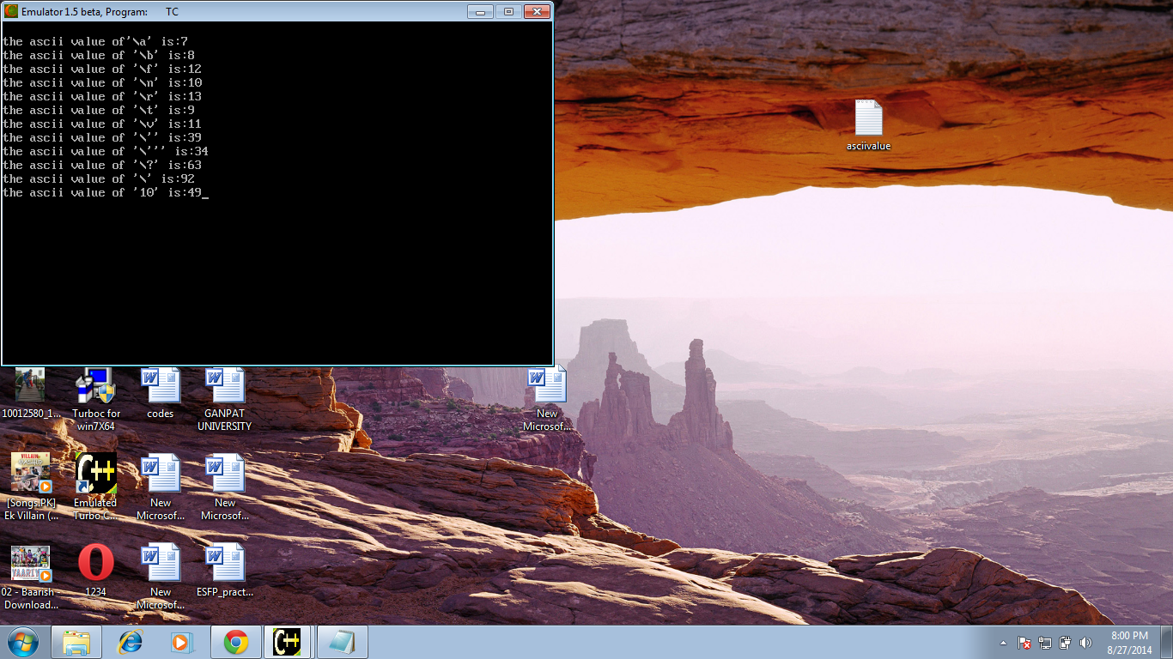
Q2. Explain different data types available in C.
Ans. C has different data types for different types of data and can be broadly classified as :
- Primary data types
- Secondary data types
Primary data types consist following data types.

Data Types in C
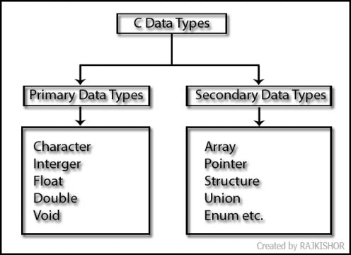Pin It

Character Type:
Character type variable can hold a single character. As there are singed and unsigned int (either short or long), in the same way there are signed and unsigned chars; both occupy 1 byte each, but having different ranges. Unsigned characters have values between 0 and 255, signed characters have values from –128 to 127.

Integer types:
Integers are whole numbers with a range of values, range of values are machine dependent. Generally an integer occupies 2 bytes memory space and its value range limited to -32768 to +32767. A signed integer use one bit for storing sign and rest 15 bits for number.

Floating Data Types:
The float data type is used to store fractional numbers (real numbers) with 6 digits of precision. Floating point numbers are denoted by the keyword float.

Double Data Types:
When the accuracy of the floating point number is insufficient, we can use the double to define the number. The double is same as float but with longer precision and takes double space (8 bytes) than float. To extend the precision further we can use long double which occupies 10 bytes of memory space.

Void Type:
The void type has no values therefore we cannot declare it as variable as we did in case of integer and float.
The void data type is usually used with function to specify its type. Like in our first C program we declared “main()” as void type because it does not return any value.

Q3. Explain about C Tokens in brief.
Ans. Tokens of the C Language
A token is a sequence of characters that is understood as a unit. Tokens are the basic building blocks of a C program. C tokens fall roughly into the six categories listed below. grouping - tokens pairs that group things together
identifiers - tokens that name functions, variables, constants, and types
literals - tokens that specify values
operators - tokens that are used to combine values in expressions
punctuation - tokens that separate or terminate complex constructions
special - tokens with special meaning to the preprocessor or compiler
In a C source program, the basic element recognized by the compiler is the "token." A token is source-program text that the compiler does not break down into component elements.
Syntax
token:
keyword
identifier
constant
string-literal
operator
punctuator
The keywords, identifiers, constants, string literals, and operators described in this section are examples of tokens. Punctuation characters such as brackets ([ ]), braces ({ }), parentheses ( ( ) ), and commas (,) are also tokens

Q4. Explain about backslash characters in C.
Ans. 1.It consist of two characters it represent single character.
2. Each escape sequence has unique ASCII value.
3. Each and every combination starts with backslash.
4. They are non printable variables.
5. It can express in terms of octal digits or hexadecimal sequence.

Escape Sequence | Represents
\a or \A | A bell
\b or \B | A backspace
\f or \F | A formfeed
\n or \N | A new line
\r or \R | A carriage return
\t or \T | A horizontal tab
\v or \V | A vertical tab
\xhh or \Xhh | A hexadecimal bit pattern
\ooo | An octal bit pattern
\0 | A null character
\\ | A backslash (\)

